**IT24102616 – Chandrasekaran.I.S**

**IT2120 – Lab 04**

**Exercise**

1. Import the dataset (’Exercise.txt’) into R and store it in a data frame called” branch data”.

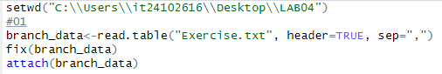

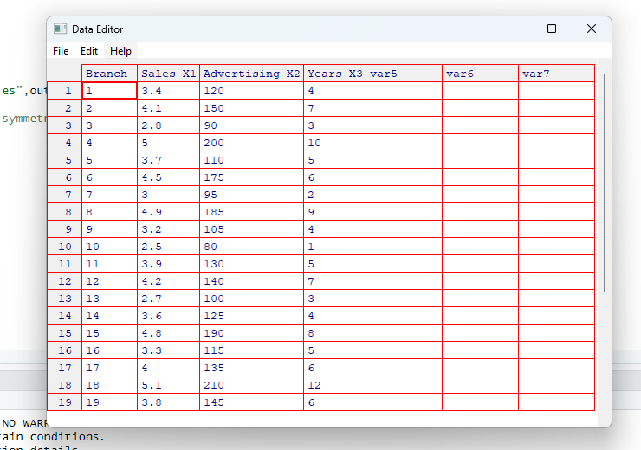

2. Identify the variable type and scale of measurement for each variable.

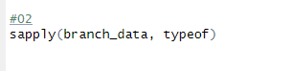

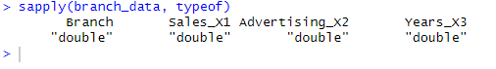

3. Obtain boxplot for sales and interpret the shape of the sales distribution.



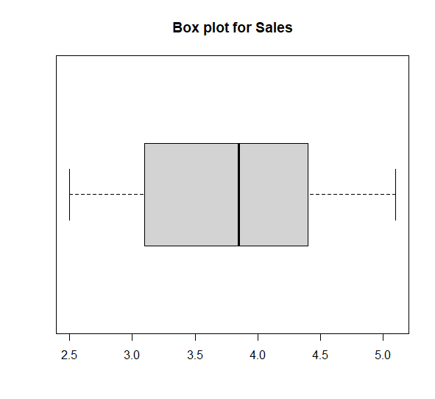

* Low data spread, data distribution is symmetric

4. Calculate the five number summary and IQR for advertising variable.

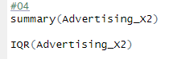

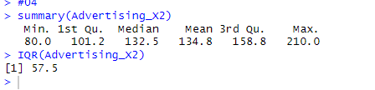

5. Write an R function to find the outliers in a numeric vector and check for outliers in years variables.

